/*The video game machines at your local arcade output coupons according to how well you play the game.
You can redeem 10 coupons for a candy bar or 3 coupons for a gumball. You prefer candy bars to gumballs.
Write a program that defines a variable initially assigned to the number of coupons you win.
Next, the program should output how many candy bars and gumballs you can get
if you spend all of your coupons on candy bars first, and any remaining coupons on gumballs. */

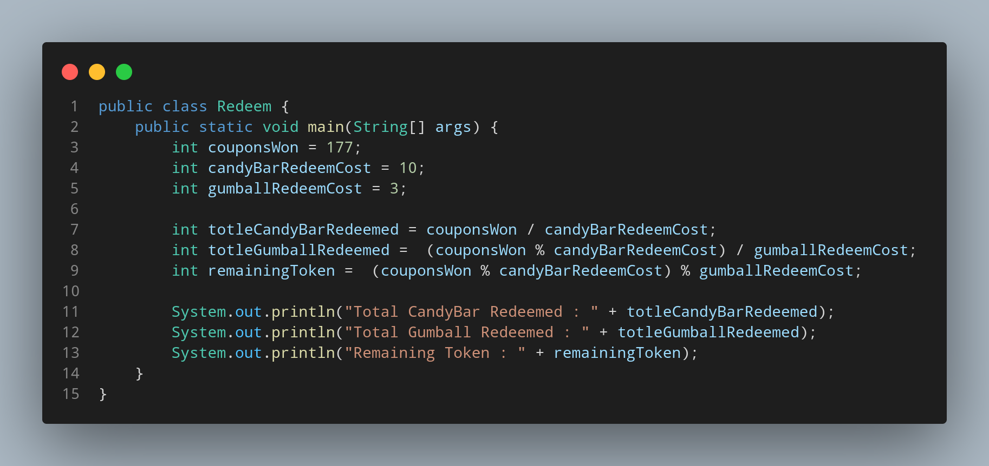

#Doc

File name Redeem is created so we create a class name Redeem, inside the class we created a main function. Then we create our varable named couponWon having data type int in order to store the number of couponwon. Two more variable are created to store the cost of coupan to reedem the candybar and gumball , we named it candyBarCost and gumballost respectively . To clacualte how much candybar can we reedem from our coupon we divided number of coupon with the cost of one candybar.
Again to calculate the number of gumball we can reedem from the remaining coupon we fid out the number of remaining coupon using modlus and then divided the remaining coupon with ost of gumball cost. Then we print the reslt with the appropriate message.

